|  |
| --- |
| ANDROID FORENSIC |
| SAAD USMAN |
| BCSP243016 |

|  |
| --- |
| ztech  [Pick the date] |

MOBILE FORENSIC –LAB

Task 1:

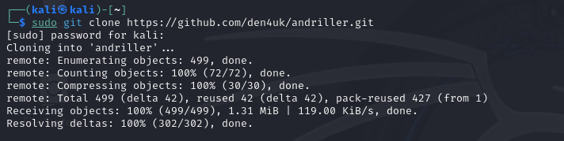

Task 2:



Task 3:



Task 4:

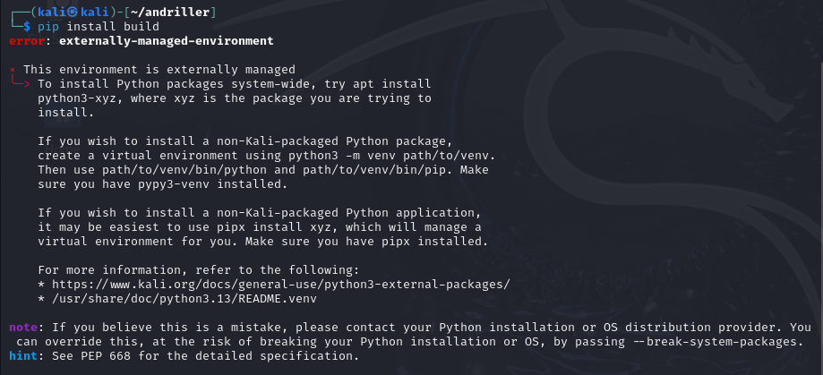

Task 5:

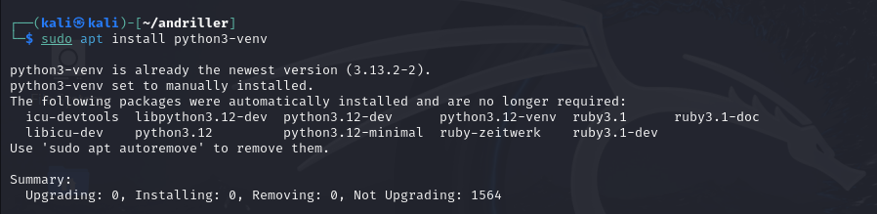

Task 6:



Task 7:

source venv/bin/activate

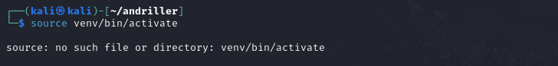

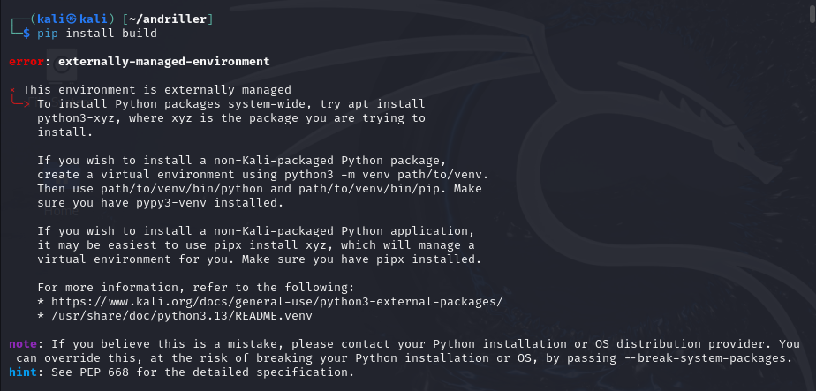

Is ko abhi use nahi karna warna phir yeh error de ga .

Task 8:

1)sudo chown -R $USER:$USER ~/andriller

2) cd ~/andriller

python3 -m venv venv

3) source venv/bin/activate

And then build command comes.

4) pip install build

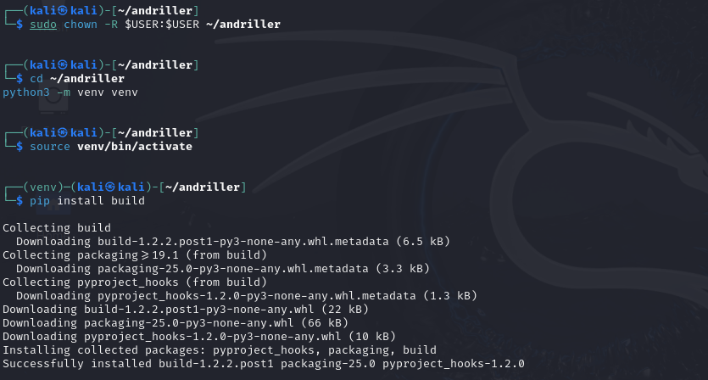

Task 9:

sudo apt install python3-venv

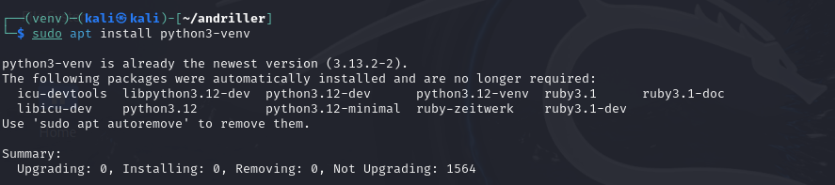

Task 10:

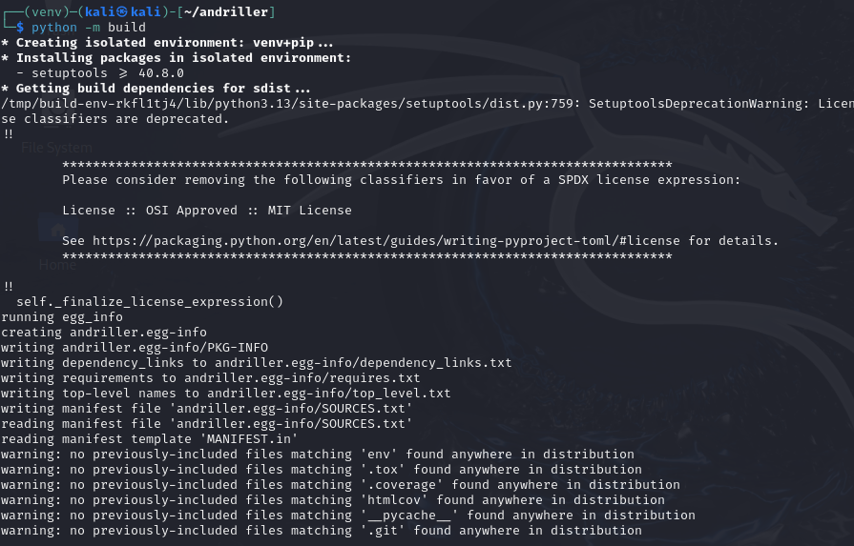

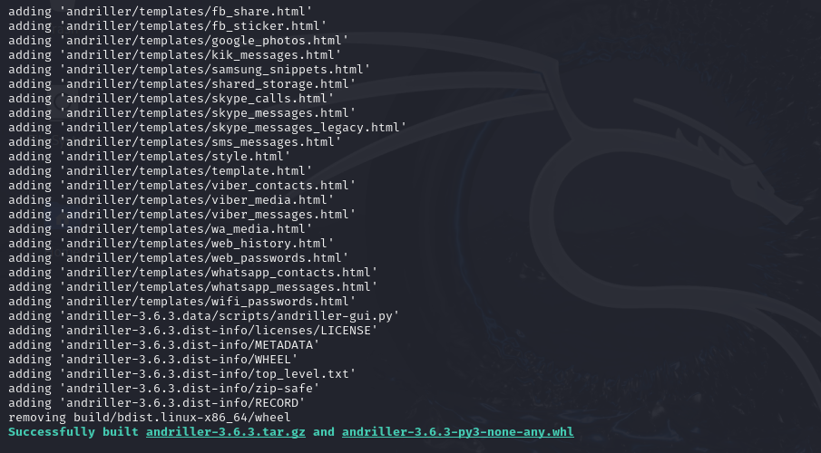

Task 11:

sudo rm -rf andriller.egg-info



Task 12:

sudo chown -R $USER:$USER ~/andriller



Task 13:

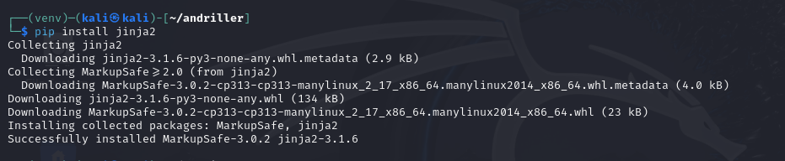

Task 14:

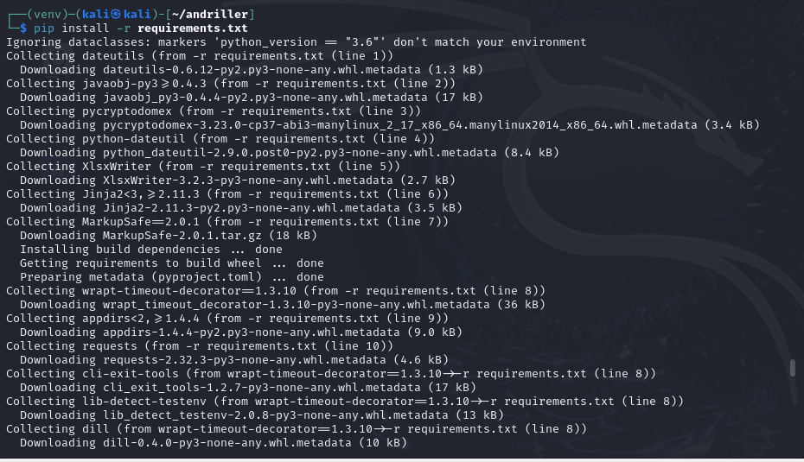

Task 15:

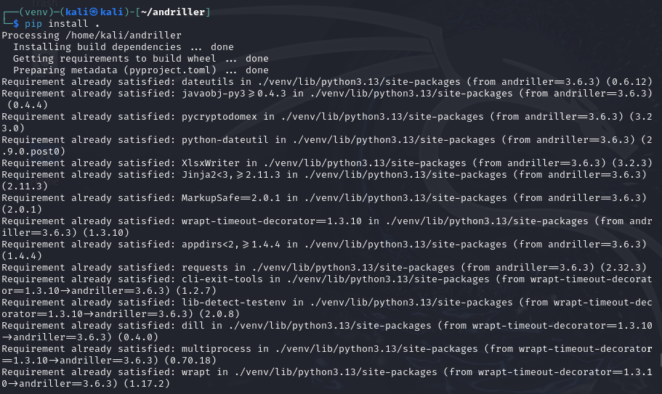

Task 16:

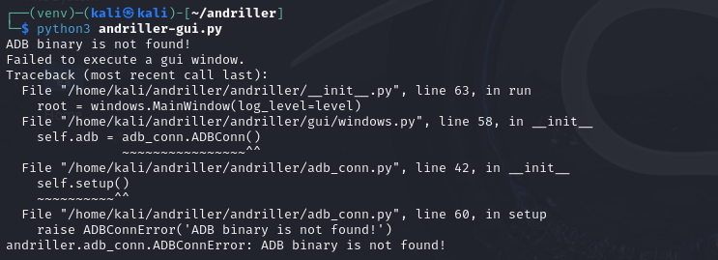

As ADB binary is not found!

Now , InshaAllah ,We will fix it .

1) sudo apt update

sudo apt install android-tools-adb

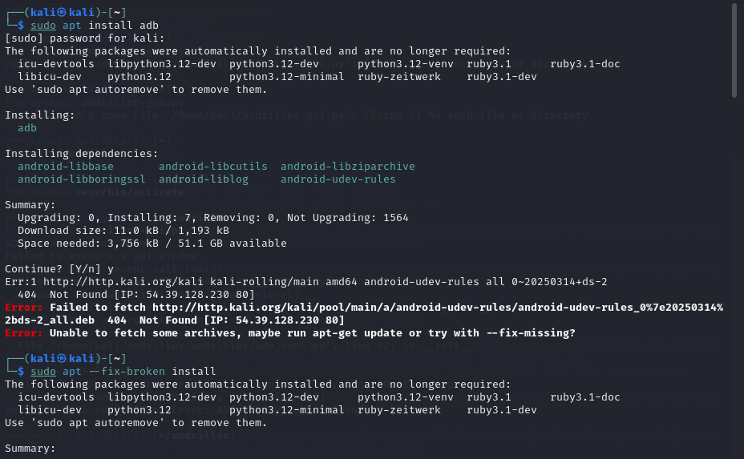

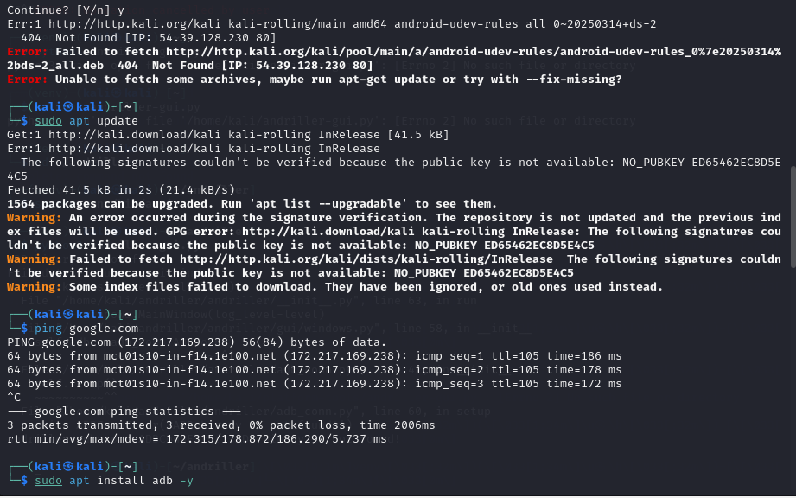

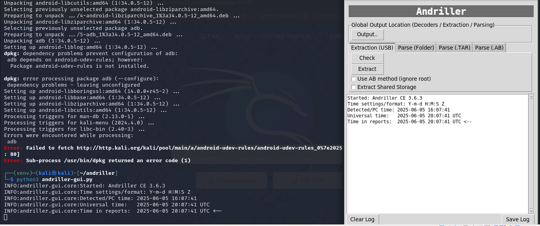

NOW STEPS:

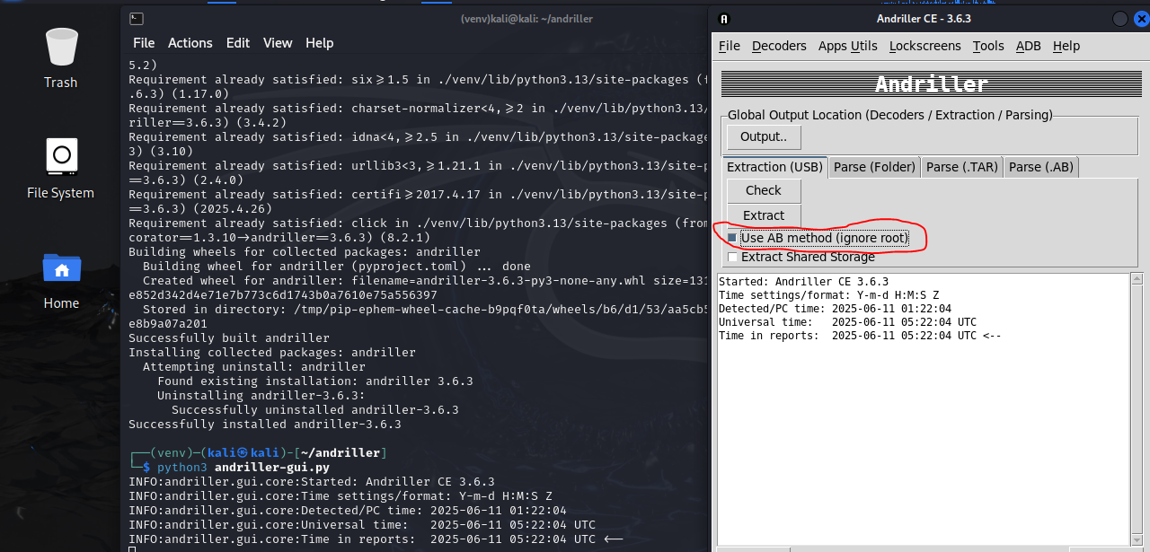

STEP 2:

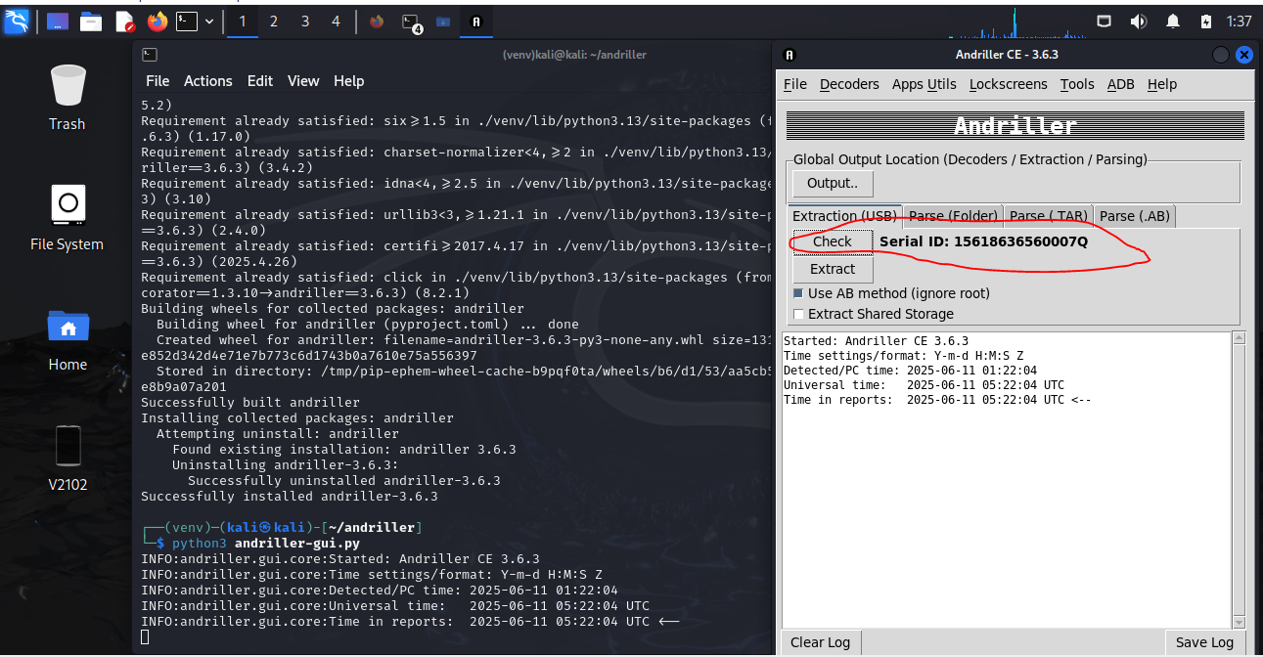

STEP 3:

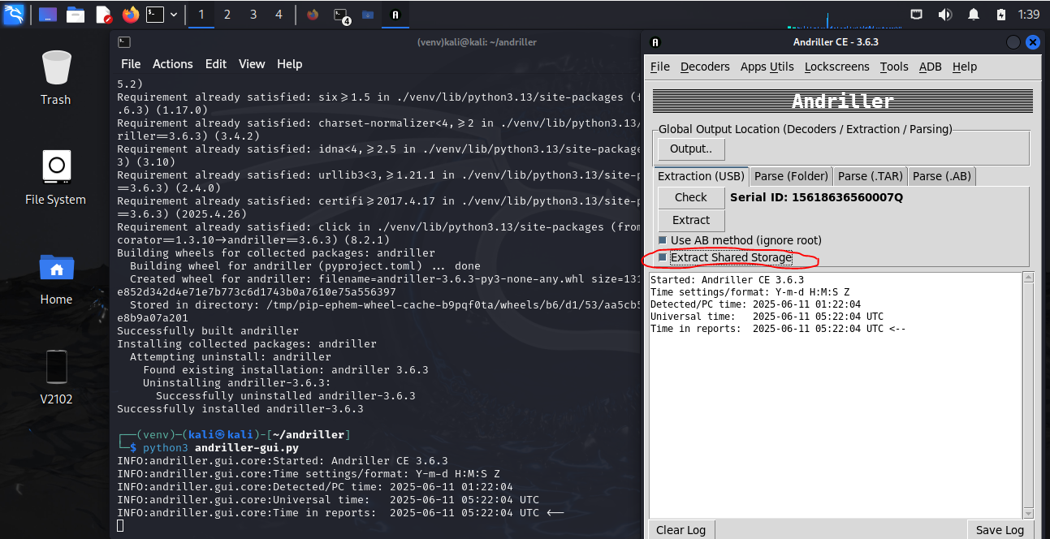

STEP 4:

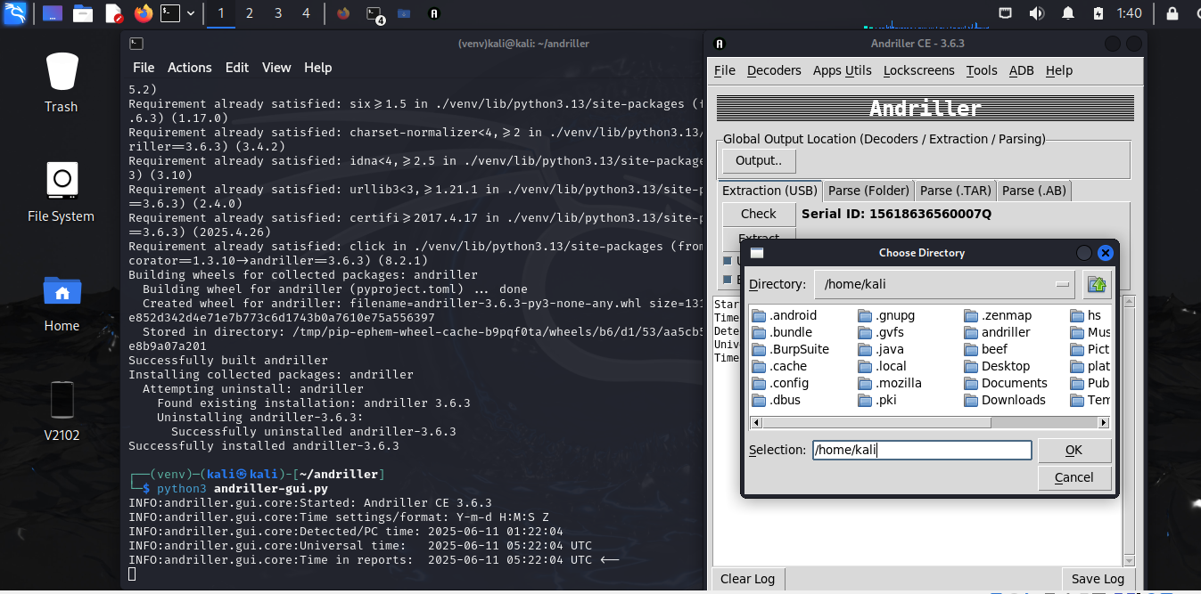

STEP 5:

OUTPUT PAR JANA HAI OR US KAY BAD HUM NAY WAHAN PAR DESKTOP CHOOSE KARNA HAI YAH PHIR KUCH OR BHI LOCATION CHOOSE KAE SAKTAY HAIN.

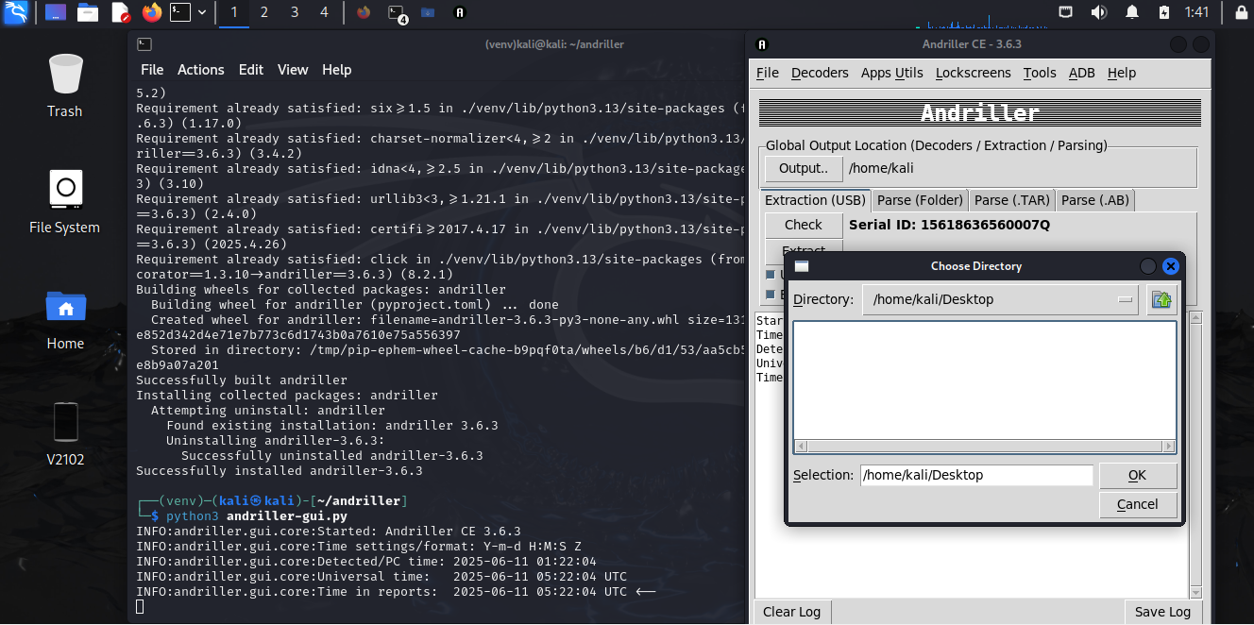

STEP 6:

AFTER SELECTING THE LOCATION PRESS EXTRACT BUTTON.

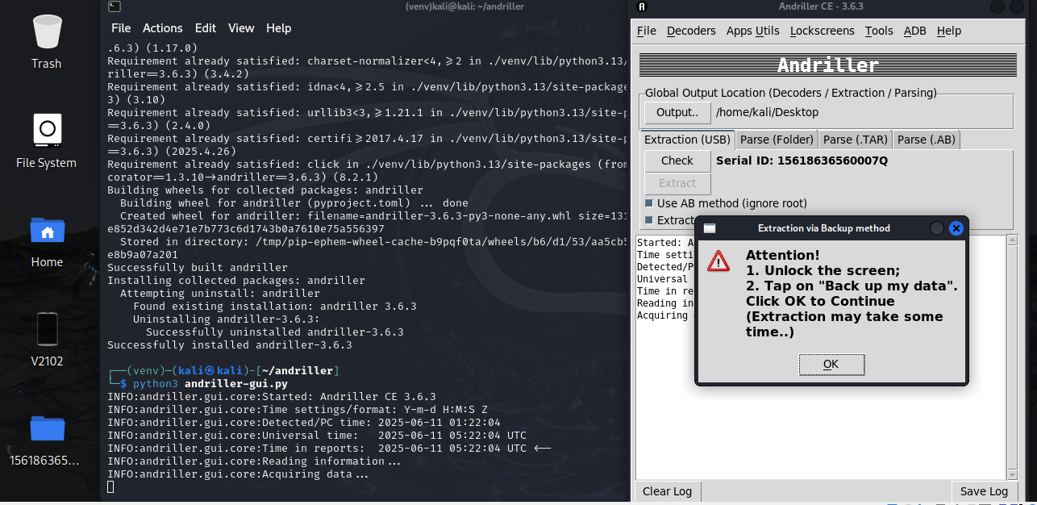

STEP 7:

CLICK ON “BACKUP MY DATA”

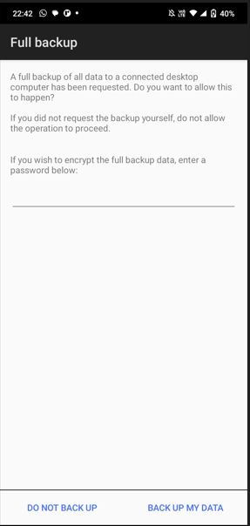

Step 8:

